The Dataset used in this model was provided by Sir Rom labelled:
TRUE = NON-INSTALLERS
FALSE= INSTALLERS
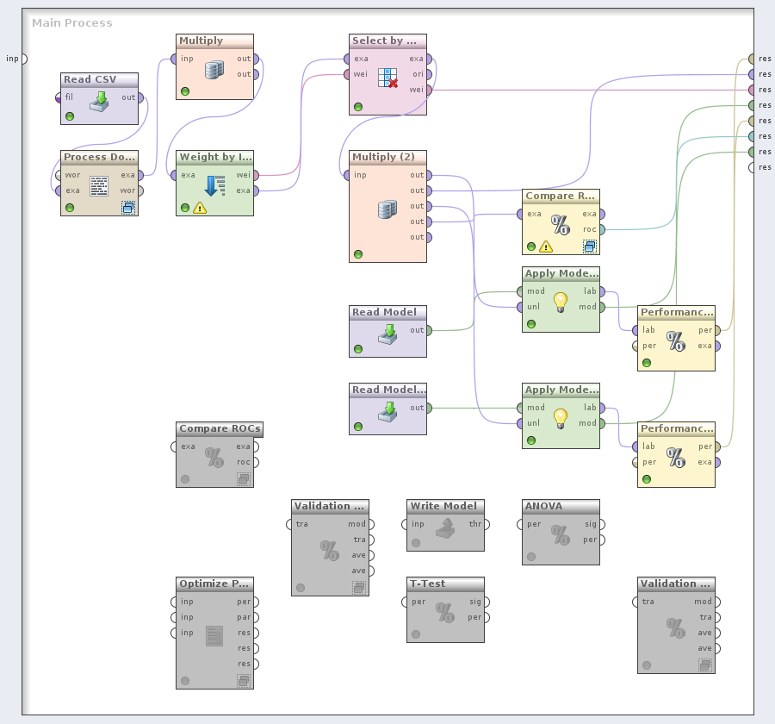

The parameters modified in Process Documents from Data object was vector creation which is set to Binary Term Occurances, the prune method was percentual which is set to prune below 3% (remove the words that appear less than this percentage of all documents) and prune above 90% (remove words that appear in more than this percentage of all documents). The researchers use this kind of method to remove attributes that will eventually overfit the model and to make the dataset to be sparse. (for more info: http://www.cs.bc.edu/~alvarez/ML/statPruning.html)

To know if the attributes selected can create a good model, Information gain was used to know the attributes relevancies. And to make a good generalization for attributes that will be used, the researchers test possible weights of attributes between 0.0 to 0.9. and it turns out that the good attributes that can be use to create the model has a weight (IG) of greater than or equals 0.2. the table below is the list of attributes use to create the model and their corresponding weight (IG).
Attributes | Weights
_calloc_crt | 0.20315128398693913
_stricmp | 0.2031542755003964
writeconsolew | 0.20435273556267836
?_xout_of_range@std@@yaxpbd@z | 0.20541747192824578
srand | 0.20541747192824578
?_type_info_dtor_internal_method@type_info@@qaexxz | 0.2076854965050969
heapalloc | 0.20836058757769013
rand | 0.20861661946381901
getconsolemode | 0.21154836284368078
_purecall | 0.21198545391902937
sprintf | 0.21249648485290684
??2@yapaxi@z | 0.21342628743374104
strncmp | 0.21395555978918504
?_xlength_error@std@@yaxpbd@z | 0.21450062303127965
strstr | 0.2147001737481596
??0exception@std@@qae@abv01@@z | 0.21677602718107847
msvcr100.dll | 0.2190532845303543
interlockedincrement | 0.2197599432511421
couninitialize | 0.2198764070438493
getmodulehandlew | 0.2210220393849737
??3@yaxpax@z | 0.22218170486427946
_wcsicmp | 0.22446897798017937
memmove_s | 0.22589620924493414
createmutexw | 0.226546888982704
interlockeddecrement | 0.2298729392448079
_time64 | 0.23046748658665286
getcurrentthread | 0.23472547990147638
tolower | 0.23504625754023686
getenv | 0.2358536776752666
openprocess | 0.23626534758741538
_close | 0.23800613574806365
getprocessheap | 0.2385521099959399
_read | 0.23911986930926607
memcpy_s | 0.23963254936060066
loadlibraryw | 0.24554466075501497
strchr | 0.2464965127558066
printf | 0.24849512001610255
fflush | 0.24958314248421754
__initenv | 0.2534368250152657
_errno | 0.25376883304361625
getuserdefaultlangid | 0.2571690265504815
wcsstr | 0.25805347611998075
fread | 0.25877731310780006
outputdebugstringw | 0.26283901471261883
fprintf | 0.2651035898189266
fwrite | 0.2696550121551285
releasemutex | 0.2714334376052097
_cxxthrowexception | 0.2788077373329187
atoi | 0.28107712465484563
exitwindowsex | 0.2837354320558775
kernel32.dll | 0.29060952894377623
getstartupinfow | 0.29966273958837264
gettickcount | 0.30317740551485634
__getmainargs | 0.30602125563715965
memmove | 0.32869187024461055
realloc | 0.3314852268149272
unhandledexceptionfilter | 0.33432107862661053
__wgetmainargs | 0.33590110969858294
calloc | 0.3382740872085476
fclose | 0.33870929871984284
heapsetinformation | 0.3398422633245554
initializecriticalsectionandspincount | 0.36096036361900163
isprocessorfeaturepresent | 0.36208277125990246
__cxxframehandler3 | 0.3736256666832883
malloc | 0.3776468463924794
3388 | 0.38564859711139066
vsdt_pkzip | 0.3955621757860096
free | 0.3999851724195737
none | 0.41085353650630774
memcpy | 0.42465640487673134
_commode | 0.4842007350814179
memset | 0.5017921026915605
setunhandledexceptionfilter | 0.5326099235995416
_xcptfilter | 0.5391160014582564
terminateprocess | 0.5734575201437991
_crt_debugger_hook | 0.5785911695485629
_controlfp_s | 0.586390150464567
_except_handler4_common | 0.586390150464567
_invoke_watson | 0.586390150464567
_fmode | 0.5994386091398739
?terminate@@yaxxz | 0.6183588652345099
queryperformancecounter | 0.6333876181736726
_exit | 0.6376748685245686
getcurrentthreadid | 0.6397162662090022
_initterm_e | 0.6416225210608372
_configthreadlocale | 0.6442810701467854
__setusermatherr | 0.6563517970995584
_initterm | 0.6563517970995584
decodepointer | 0.6574286752003948
encodepointer | 0.6574286752003948
__dllonexit | 0.6773798025015667
__set_app_type | 0.6799266550521051
exit | 0.6820324491156957
6062336 | 0.6938345852999143
isdebuggerpresent | 0.6983508662552782
_onexit | 0.6989029677795716
_amsg_exit | 0.7429043265431834
_lock | 0.7565701515317058
_unlock | 0.7565701515317058
_cexit | 0.764145885995009
getsystemtimeasfiletime | 0.8667845719484165
getcurrentprocessid | 1.0

In creating the model, the researchers use logistic regression since the dataset is not quite large. And use bagging to further enhance the reduction of overfitting of the model. The picture below shows the ROC curve of the model.
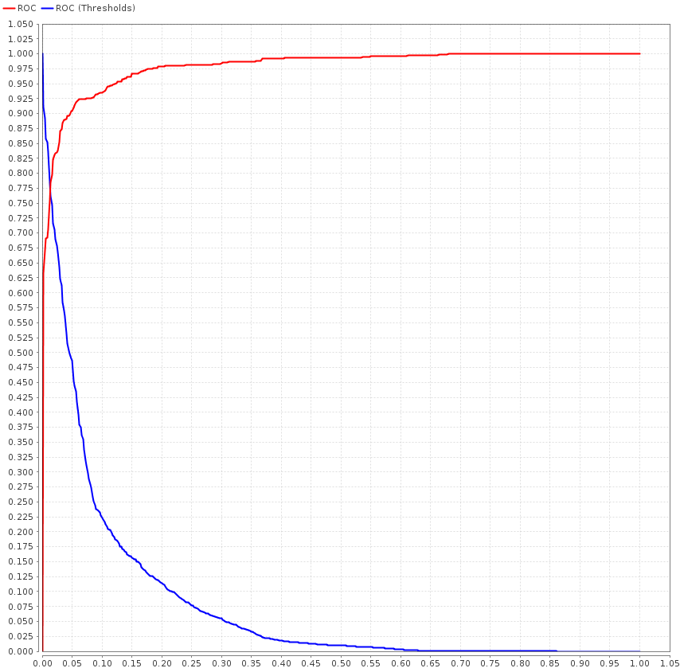
The Area under the Curve (AUC) of the model created was 0.979.

it shows that as the threshold in the test set (blue curve) gets closer and closer to 1, the plot (red curve) of the True positive rate (y-axis) icreases and the false positive rate (x- axis) remains the same until it reaches a high threshold. The closer the curve follows the left-hand border and then the top border of the ROC space, the more accurate the test.

The following shows the Confusion matrix in coss validation test:

accuracy: 91.76% +/- 2.30% (mikro: 91.76%)

 | true TRUE | true FALSE | class precision
pred. TRUE | 1474 | 113 | 92.88%
pred. FALSE | 84 | 719 | 89.54%
class recall | 94.61% | 86.42%

Remarks

Intutively, this model does not gurantee to correctly predict non-installers. Because it only uses relatively small attributes. Further attribute selection is suggested. Although the attribute .msi was a good attribute, it was remove in prunning because as the prunning suggested, the said attribute can overfit the model.

